ELICITATION PLAN TEMPLATE
Finding Information
Sources of information may be:
- Questionnaire (survey)
- Interviews with user
Prepare for Elicitation
Elicitation preparation may be formal or informal. Elicitation preparation is the planning performed to conduct an effective elicitation session.
Interview Notes:
Interviewee: Youssef Karim
Date: 26/10/2025
Notes:
Questions | Answer | Observation
How often do you feel stuck not knowing what to cook, even though you have ingredients at home? | “Almost every day, especially at night.” | Strong pain point: opportunity for daily-use feature.
How important is it for you to see nutrition information (calories, protein, etc.) when choosing a recipe? | "Important" | Nutrition is important but must be simple and clear.
How do you currently find recipes (for example: YouTube, Google, TikTok, cookbooks, family)? What do you like or dislike about these methods? | "YouTube, virtual, different languages” | User/customer is not sure how to decide
Have you ever thrown away food because it expired or you did not know how to use it? How often does this happen? | "Yes, twice a month" | Confirms food-waste problem; supports requirement for using existing ingredients.

Elicitation Techniques
- Interviews.
- Questionnaires and Surveys.
Acceptance Criteria
SCREEN TEMPLATE
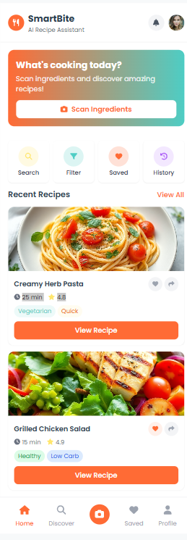

Requirements Management

Verify Requirements
Requirements verification is the process of reviewing requirements to ensure the requirements are constructed properly and are error free. It involves conducting peer reviews and identifying inconsistencies to meet quality standards. Per the Project Management Institute, the following characteristics are present in all well-written, high-quality requirements:
Functional Requirements:
ID | Description | Priority
FR-01 | The System should allow Users to Login or Register. | Medium
FR-02 | The System should allow Users to Logout or delete accounts. | Medium
FR-03 | The System should allow Users to edit on their accounts. | Medium
FR-04 | The System should ask Users to give access to the camera and gallery. | High
FR-05 | The AI photo scanner should detect ingredients. | High
FR-06 | The AI photo scanner should generate recipes. | High
FR-07 | The System should show detail of recipes. | Medium
FR-08 | The System should allow Users to share and filter. | Low
FR-09 | The Users have the option to subscribe to remove ads. | Medium
FR-10 | The admin should be able to monitor User activity and usages statistics and feedback. | High
FR-11 | The admin should be able to manage refunds requests, subscription and ads. | High

Non-Functional Requirements:
ID | Category | Requirement
NFR-01 | Performance | The AI photo scanner must scan photos within 10 seconds.
NFR-02 | Peformance | The AI recipe generation must be under 10 seconds.
NFR-03 | Security | Users Data must be encrypted.
NFR-04 | Security | Database must have encryptions.
NFR-05 | Security | The System must support 2FA.
NFR-06 | Reliability | The System should maintain an uptime of 98% per month.
NFR-07 | Reliability | If a critical service fails a backup service should be available within 60 seconds.
NFR-08 | Scalability | The System should be able to withstand 5000 Users at once.
NFR-09 | Usability | Interface must be consistent, Modern and easy to understand.
NFR-10 | Usability | Error messages must be clear.
NFR-11 | Usability | AI must be able to detect rotten ingredients
NFR-12 | Compatibility | The System must be available on android, IOS and Web.

Validate Requirements
Requirements validation is used to evaluate that all requirements accurately reflect the intent of the stakeholder, thereby ensuring requirements meet stakeholder expectations. Validation is typically performed by conducting a walkthrough of the requirements with stakeholders to confirm the requirements as stated are valid and will deliver the anticipated value. Select One validation technique for this project and remove the extraneous ones below.
- Traceability Matrix. A grid that allows for linkages between objects. A traceability matrix can be used to trace requirements to other types of requirements in the hierarchy
TRACEABILITY MATRIX TEMPLATE
Req ID | Source | Related Use Case | Design Element | Test Case
FR-06 | Questionnaire Q1 & Q3 (importance of personalized recipes) | UC-8 – Generate recipe based on ingredients | Recommendation Module | TC-01 – Verify app generates recipes from entered ingredients
FR-08 | Questionnaire Q3 (Saving favorite recipes) | UC-5 – Save, Share, Sort, and Filter recipes | Recipe Management Module | TC-02 – Verify user can save and view favorite recipes
FR-05 & FR-06 | Questionnaire Q6 (dietary restrictions) | UC-7 – Detect ingredients & UC-8 – Generate recipe | AI Personalization Engine | TC-03 – Verify recipes adapt to selected dietary restrictions
FR-07 | Questionnaire Q3 (Nutrition facts importance) | UC-9 – Calculate calories and recipe details | Nutrition Analysis Module | TC-04 – Verify nutritional information is calculated correctly

Change Request:
CR Number: CR-01
Requested By: Smart Bite Team
Date: 02/12/2025
Description of Change: Update the recipe screen layout to make the ingredients and steps easier to read.
Reason for Change: Users mentioned in the questionnaire that step-by-step instructions and clear ingredient lists are important. Improving layout increases usability.
Impact Analysis:
• Affected Requirements:
- FR-1: Personalized recipe display
- FR-2: Recipe saving and viewing
• Affected Diagrams:
- UI mockups (only visual changes)
- No changes to use cases
• Risks:
- Minor delay in UI design updates
- No technical risks
Approved?
☐ Yes
☑ No
Updated SRS Version: Version 1.0.1

